|  |
| --- |
| [School Logo](https://www.stilltydsschool.co.uk/) |
| **Relationship Policy**  *Summer Term 2023* |
| At Saint Illtyd’s with God’s love we play, learn and grow together |

# SCHOOL DETAILS

**Name**: St Illtyd’s Primary School

**Address**: Jersey Road,

Bon-y-Maen

Swansea

SA1 7DG

**Head Teacher**: Mrs Maria Davies

**Web**: https://www.stilltydsschool.co.uk/

**Email**: [St.Illtyds.School@swansea-edunet.gov.uk](mailto:St.Illtyds.School@swansea-edunet.gov.uk)

**Phone**: 01792 462104

DOCUMENT VERSION CONTROL

|  |  |  |  |
| --- | --- | --- | --- |
| **Version Number** | **Purpose/Change** | **Author** | **Date** |
| 0.1 | Draft behaviour policy | M.Davies | December 2021 |
| 1.0 | Relationship policy | M.Davies/J. Mowbury | June 2022 |
|  |  |  |  |
| **Next review date – ANNUAL REVIEWS** | | | |

Policy agreed by Governors:

….………………………………………….………………… (Signed by Chair)

………………………………………………. Date

***School Vision***

St Illtyd’s is a Catholic school of the Diocese of Menevia in which each individual grows in the knowledge and love of Christ. In partnership with parents and the whole community, our purpose is to provide a high standard of education, giving the maximum opportunity to realise each person’s potential.

We believe that to make this vision a reality, we must:

* Follow the example of Christ and in so doing, treat our children, families and staff with dignity and respect.
* Help our children and families and each other know of God’s love for all of us and to learn about the message of Christ through the Gospels.
* Provide a high quality, inclusive education for all where creativity and personality are allowed to blossom and thrive and where independence, motivation and perseverance become life-long skills.
* Nurture all individuals to develop confidence in themselves and have high self-esteem and ensure that the children achieve their full potential in all areas of the curriculum.
* Encourage and motivate a highly skilled team of staff and continually develop our knowledge to ensure the best possible education for all of our children.
* Recognise the immense potential of working in partnership with the children’s families, the Parish and wider community in order to fulfil our wider ambitions for the children in our school.
* Support our children, their families and each other in the faith journey, in developing a knowledge and understanding of the traditions of the Catholic Church which include sacramental preparation.
* Foster in the children, respect for themselves and all human-beings and the environment and society in which they live so that they grow into kind and caring young people who respect others regardless of their faith or cultural backgrounds.

# **1. Behaviour**

Our mission statement ‘We play, learn and grow together’ states that we areusing the life of Jesus Christ as a model. This policy has been created in collaboration with both staff and pupils.

St Illtyd’s is a school where children are taught a broad and balanced curriculum by highly skilled staff and the academic standards are high. However, St Illtyd’s is more than this; it is about our Catholic faith that teaches children to follow the example of Jesus, enabling everyone to shine and be proud. We teach the children to have pride in themselves and to work harmoniously with others; it is also a place of acceptance and respect for the beliefs of others and pride in what others do well.

## **1.2 AIMS**

It is a primary aim of St Illtyd’s Primary School that every member of the school community feels valued and respected, and that each person is treated fairly. We are a community, whose values are built on mutual trust and respect for all. The school’s behaviour policy is therefore designed to support the way in which all members of the school can work together in a supportive way. It aims to promote an environment in which everyone feels happy, safe and secure.

Our behaviour policy is a means of promoting good relationships, so that we can work together with the common purpose of helping everyone to learn.

This policy aims to help children grow in a safe and secure environment, and to become positive, responsible and increasingly independent members of the school community.

The school recognises and promotes good behaviour, as it believes that this will develop an ethos of kindness and cooperation. This policy is designed to encourage good behaviour, rather than merely deter anti-social behaviour.

**2. ROLES AND RESPONSIBILITIES**

Behaviour Management is the responsibility of all staff at St Illtyd’s Primary School.

The Headteacher supports the staff by implementing the policy, by setting the standards of behaviour, and by supporting staff in their implementation of the policy.

The Headteacher keeps records of reported serious incidents of misbehaviour by recording major incidents in My Concern.

**2.1 ROLE AND RESPONSIBILITY OF CLASSROOM STAFF**

It is the responsibility of all staff to ensure that the school code of conduct is respected in their classes and around the school, and that children behave in a responsible manner throughout the school day.

All staff in our school have high expectations of the children with regard to behaviour and relationships, and they strive to ensure that all children work to the best of their ability.

All staff are a role model for the children and treat each child fairly, promoting the classroom code consistently. Staff treat all children with respect and understanding.

The class teacher reports to parents and carers about the progress of each child in their class, in line with the whole-school policy. The class teacher may also contact a parent (in discussion with the ALNco and the Headteacher) if there are concerns about the behaviour or welfare of a child.

**2.2 THE ROLE OF PARENTS AND CARERS**

The school collaborates actively with parents and carers, so that children receive consistent messages about how to behave at home and at school. We work in partnership with parents and carers to support their child’s learning and behaviour in school.

**3. LEARNING ATTITUDES AND BEHAVIOURS**

At St Illtyd’s Primary School we believe that children need to be given the opportunity to develop key learning attitudes and behaviours to achieve their potential. As a school, we evaluate the extent to which pupils are developing the key attitudes and behaviours that will help them to learn. Pupils who lack confidence in their ability are identified and interventions are put in place to support their learning. In collaboration with the staff and children we have introduced eight areas of learning behaviours within our classrooms that will empower and enhance pupil’s attitudes to learning. The children decided on logos and headings of each of the learning behaviours. Our House Point system links to the learning behaviours, teachers award points against a learning behaviour. Our weekly reward assembly, ‘Seren Yr Wythnos’, is also linked to learning behaviours. House points are awarded for the following -

 Siarad Cymraeg  Participation

 Reflection  Team work

 Organisation  Investiagtion

 Independence Citizenship

Children also receive house points for demonstarating the four core purposes of the Curriculum –

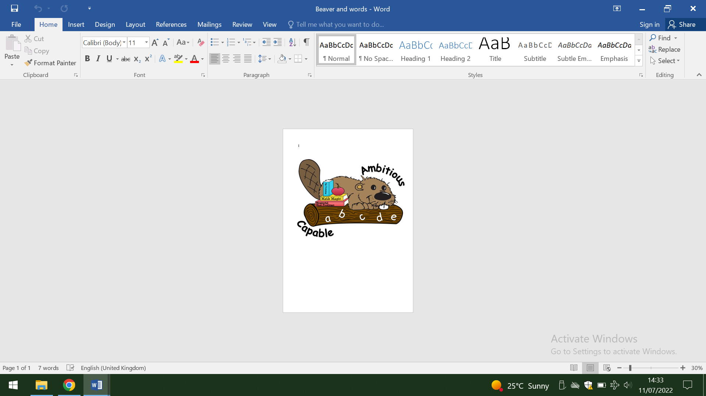 Ambitious and capable 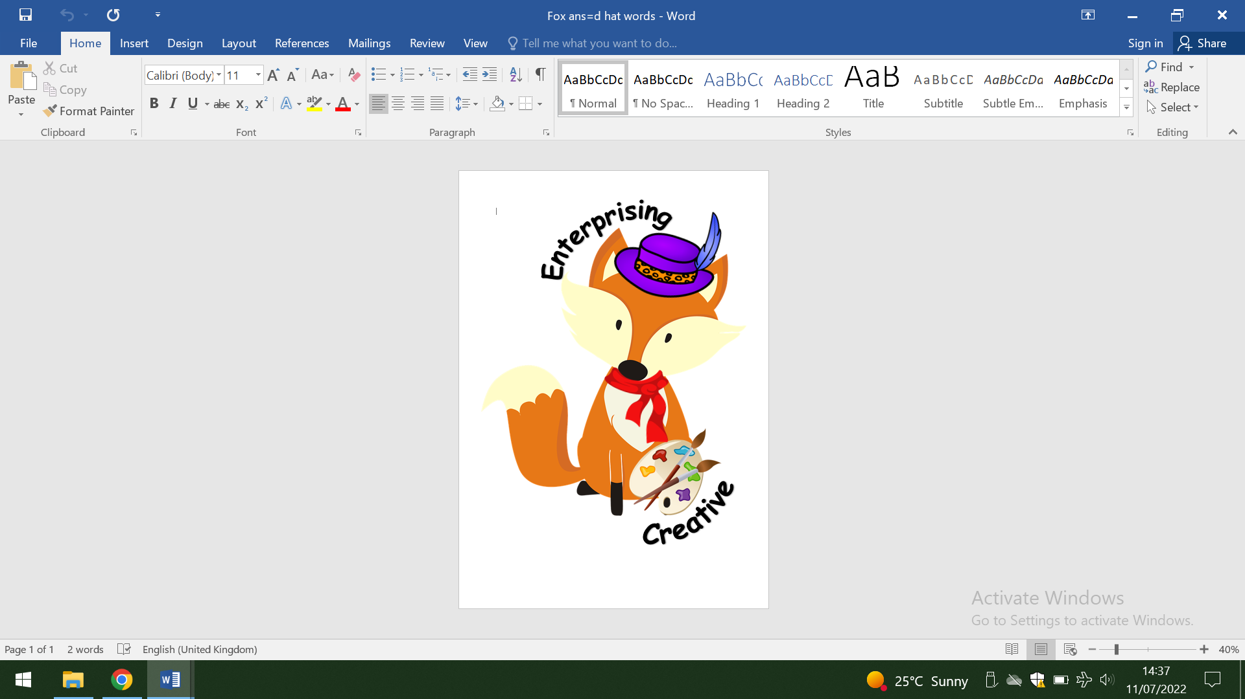Creative and enterprising

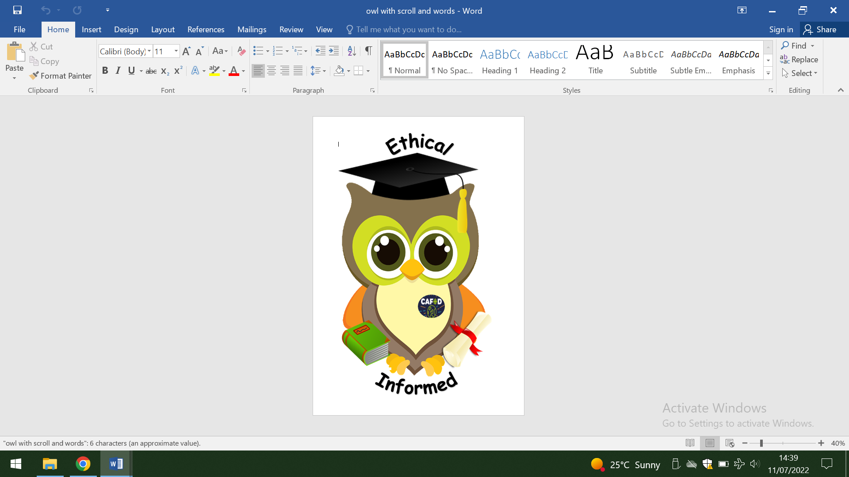Ethical and informed 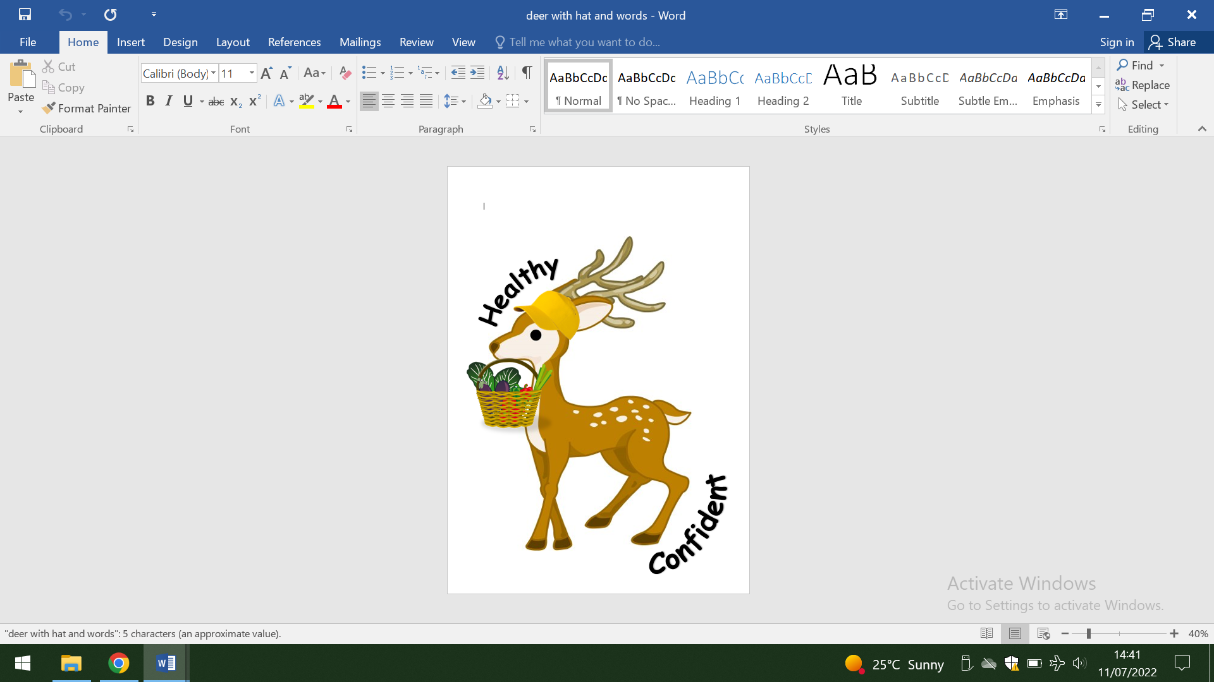 Healthy and confident

**4. PROMOTING POSITIVE BEHAVIOUR**

* Good quality teaching
* Clear and consistent high expectations
* Praise for good behaviour
* Celebrating success by issuing house points (sharing learning in class, with Leadership Team, during ‘Seren Yr Wythnos’ assembly, with parents)
* The Head teacher actively encourages staff members to send children to her for good behaviour, improved attitudes to learning, and outstanding achievement.
* Class and whole-school assemblies make use of appropriate stories and real-life experiences to reinforce a positive and moral ethos
* Children involved in making the rules
* Children involved in agreeing consequences
* Children are listened to and given the opportunity to discuss issues relating to behaviour so that they can adapt their behaviour in the future and learn from their mistakes
* Recognition when behaviour has improved
* Giving children responsibility for areas around the school or helping adults

**5. REWARDS AND HOUSES**

Each child at St Illtyd’s Primary is either part of St Cadoc, St Derfel, St Non or St Winifred house. House points are given for promotion of good learning behaviours. House Captains and Vice Captains have been selected to count weekly house points and report back to the children during assemblies. House Captains run competitions where children have the opportunity to gain more points for their Houses. We celebrate weekly the number of House Points awarded across the school to help the children appreciate their contribution towards the ethos of the school.

A weekly award assembly takes place, ‘Seren Yr Wythnos’. Two children from every class are awarded a certificate in order to celebrate good work.

**6. CONSEQUENCE CHARTS/SANCTIONS**

Each Classroom has a visible Consequence Chart. Children receive warnings for each time they break a rule from the Code of Conduct.

* Warning one - a verbal warning with initials being placed onto the Consequence Chart.
* Warning two - a time out session in Foundation Phase and missed play in KS2, again this is recorded by adding initials to the chart.
* Warning three is a visit to the Headteacher, this results with the incident being recorded in My Concern and parents being informed if the Headteacher feels that the pupil is a persistent offender or the behaviour demonstrated is deemed as serious.

The application of the consequences is at the teachers’ discretion depending on the severity of the behaviour. If children demonstrate good behaviour after being placed on the chart they are able to remove their initials from the warning boxes.

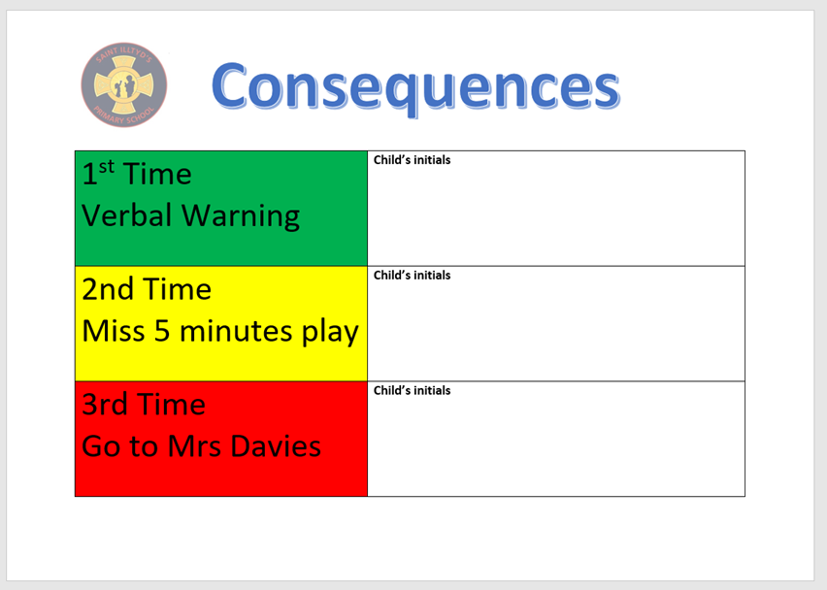

**7. CHILD FRIENDLY BEHAVIOUR POLICY**

The pupils have designed a child friendly version of the policy to ensure that all children have a clear understanding of behaviour expectations along with the rewards and sanctions for both appropriate and inappropriate behaviour. (Appendix 1)

# **8. CHALLENGING BEHAVIOUR**

Pupils with emotional, social and behavioural difficulties will often persistently challenge class and playground rules to such an extent that in serious cases a Risk Assessment may be required.

If a pupils’ behaviour is not improved by the consistent use of rewards and sanctions listed in the school Behaviour Policy, then it is possible they have a special need. Consultation with the Headteacher and Senior Leadership Team can lead to advice on the use of more specific techniques. If little or no progress is made, then and individual education plan will be required. (See ALN Policy)

# **9. exclusionS**

In most cases exclusion will be the last resort after a range of measures have been tried to improve the pupils’ behaviour.

Exclusion will only be considered where the educational entitlement and the well-being and safety of the pupil concerned, the staff and the rest of the pupils in the class/school, is jeopardised. The Headteacher informs the LA and the governing body about any permanent exclusion, and about any fixed-term exclusions beyond five days in any one term.

The formal reasons whereby the school may consider the exclusion of a pupil would be:

* In response to serious breaches of the Behaviour Policy.
* If, by allowing the pupil to remain in school, the education or welfare of the pupil or others in the school would be seriously harmed.

**Factors to consider before making a decision to exclude**

* Ensure that a thorough investigation has been carried out.
* Consider all the evidence available to support the allegations, taking account of the school’s Behaviour policy, where applicable, and the Equality Act 2010 as amended.
* Allow the pupil to give his or her version of events.
* Check whether the incident may have been provoked, for example by bullying, including homophobic bullying, or by racial or sexual harassment.
* If necessary, consult others, but not anyone who may later have a role in reviewing the Head Teacher’s decision, for example a member of the governing body.

The governing body has a discipline committee which is made up of between three and five members. This commit considers any exclusion appeals on behalf of the governors

**9. PUPILS WITH ADDITIONAL LEARNING NEEDS and EQUALITY ACT 2010**

St Illtyd’s Primary ensures that Statutory guidance on Equality Act 2010 and identifying, assessing and making provision for learners with ALN, including those with behavioural, social and emotional needs, is given in the Special Educational Needs Code of Practice for Wales is adhered to. School governing bodies have a statutory duty to do their best to ensure that the necessary provision is made for any learner with protected characteristics i.e disability; race; religion; gender reassignment; sex and sexual orientation and any learner who has an additional learning need.

Other than in the most exceptional circumstances, schools should avoid permanently excluding learners with statements of ALN. It is extremely important that parents/carers of learners with ALN who are excluded from school receive advice on the options available for their child’s future education.

The 2010 Act does not prohibit schools from excluding learners with a protected characteristic but does prohibit schools from excluding learners because of their protected characteristic (e.g. excluding a disabled learner because of their disability or because of their racial group) or discriminating unlawfully during the exclusions process. This applies to permanent and fixed-term exclusions.

St Illtyds RC Primary

[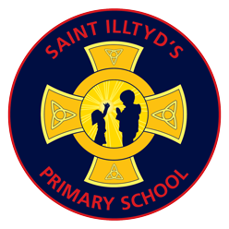](https://www.stilltydsschool.co.uk/)

Child friendly Behaviour Policy





What happens if we behave appropriately?

We earn house points for our team.

We get praise from our teachers.

We may get the ‘Head Teachers Award’.

We could be awarded a ‘Seren yr Wythnos’ certificate.

Your name goes on the consequence chart –

1st Time - Verbal warning

2nd Time - Miss 5 minutes play

3rd Time - Go to Mrs Davies

What happens if we don’t behave appropriately?

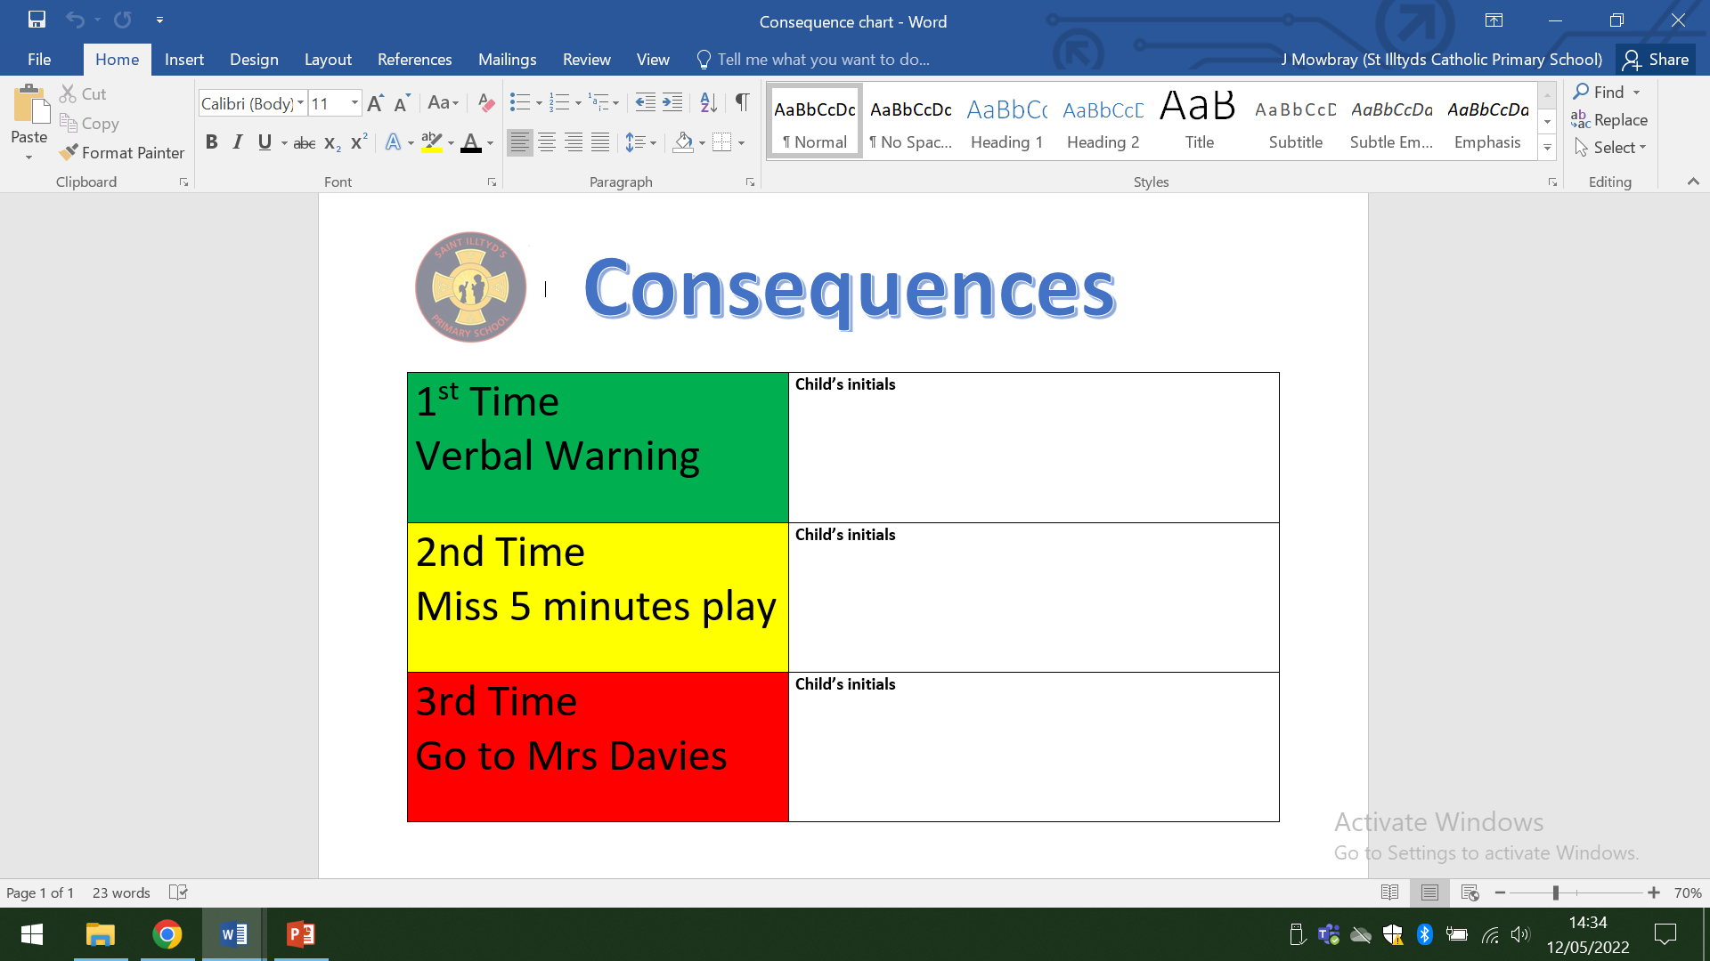

How should we behave?

These are our school rules that have been created by all pupils at St Illtyd’s –

Follow Jesus example and act in a kind way.

Respect the school’s property and each other’s property.

Remember to be polite and have good manners.

Treat other people that way you would like to be treated.

Make at least one person smile each day.

Be honest and truthful.

Use kind words and be a good friend.

Always try your best.

Listen to one another.

Appreciate the school environment and look after wildlife and the habitats.

What do we want St Illtyds School to be like?

We want our school to be a kind, happy place to learn. We want children a have a positive experience at school and follow Jesus’ example of love, kindness and forgiveness.

