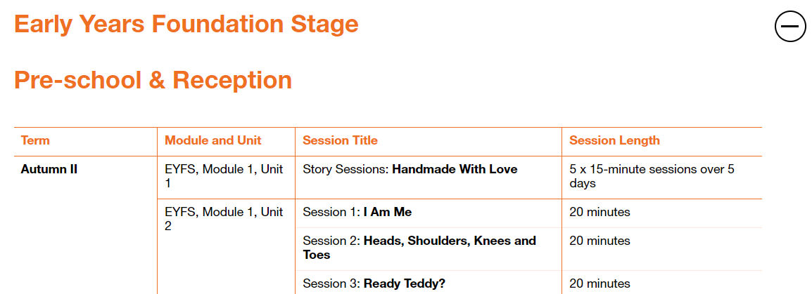

Please fill in the table below showing when you have taught a session. These will be collected in at the end of the term. This gives you the flexibility to teach the sessions as and when.

|  |  |  |
| --- | --- | --- |
| Module and Unit | Session Title | Date completed |
| Nursert  Module 1, Unit 1 | Story sessions Handmade with love (5 x 15 mins) |  |
|  |  |  |
| Reception  Module 1, Unit 2 | 1. I am me |  |
|  | 1. Heads, shoulders, knees and toes |  |
|  | 1. Ready Teddy? |  |