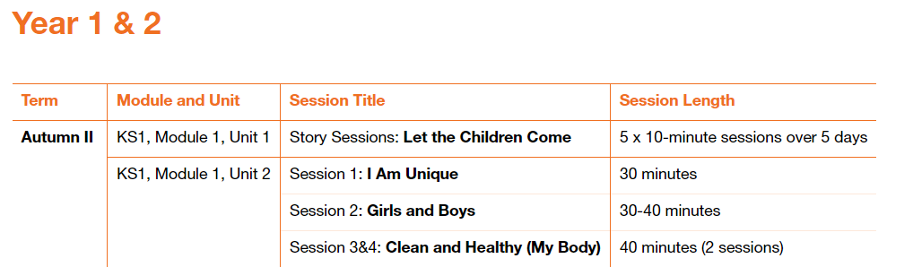

Please fill in the table below showing when you have taught a session. These will be collected in at the end of the term. This gives you the flexibility to teach the sessions as and when.

|  |  |  |
| --- | --- | --- |
| Module and Unit | Session Title | Date completed |
| Year 1  Module 1, Unit 1 | Story sessions Let the Children come |  |
|  |  |  |
| Year 2  Module 1, Unit 2 | 1. I am Unique |  |
|  | 1. Girls and Boys |  |
|  | 1. Clean and Healthy (My Body) |  |