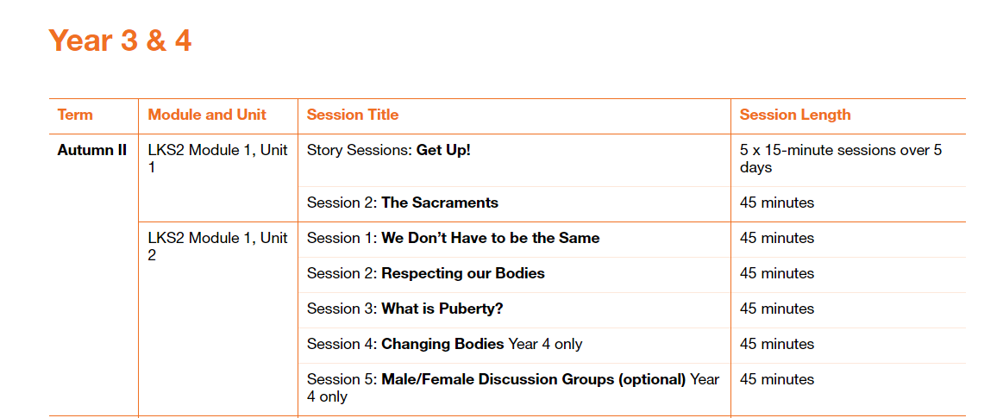

Please fill in the table below showing when you have taught a session. These will be collected in at the end of the term. This gives you the flexibility to teach the sessions as and when.

|  |  |  |
| --- | --- | --- |
| Module and Unit | Session Title | Date completed |
| Year 3  Module 1, Unit 1 | Story sessions Get up! |  |
|  | The Sacraments |  |
| Year 4  Module 1, Unit 2 | 1. We don’t have to be the same |  |
|  | 1. Respecting our bodies |  |
|  | 1. What is puberty? |  |
|  | 1. Changing bodies (Year 4 only) |  |
|  | 1. Male and female discussion groups. (Year 4 only – optional) |  |