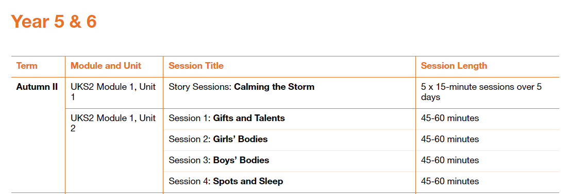

Please fill in the table below showing when you have taught a session. These will be collected in at the end of the term. This gives you the flexibility to teach the sessions as and when.

|  |  |  |
| --- | --- | --- |
| Module and Unit | Session Title | Date completed |
| Year 5  Module 1, Unit 1 | Story sessions – Calming the Storm |  |
|  |  |  |
| Year 6  Module 1, Unit 2 | 1. Gifts and Talents |  |
|  | 1. Girls’ Bodies |  |
|  | 1. Boys’ Bodies |  |
|  | 1. Spots and Sleep |  |