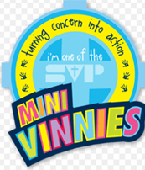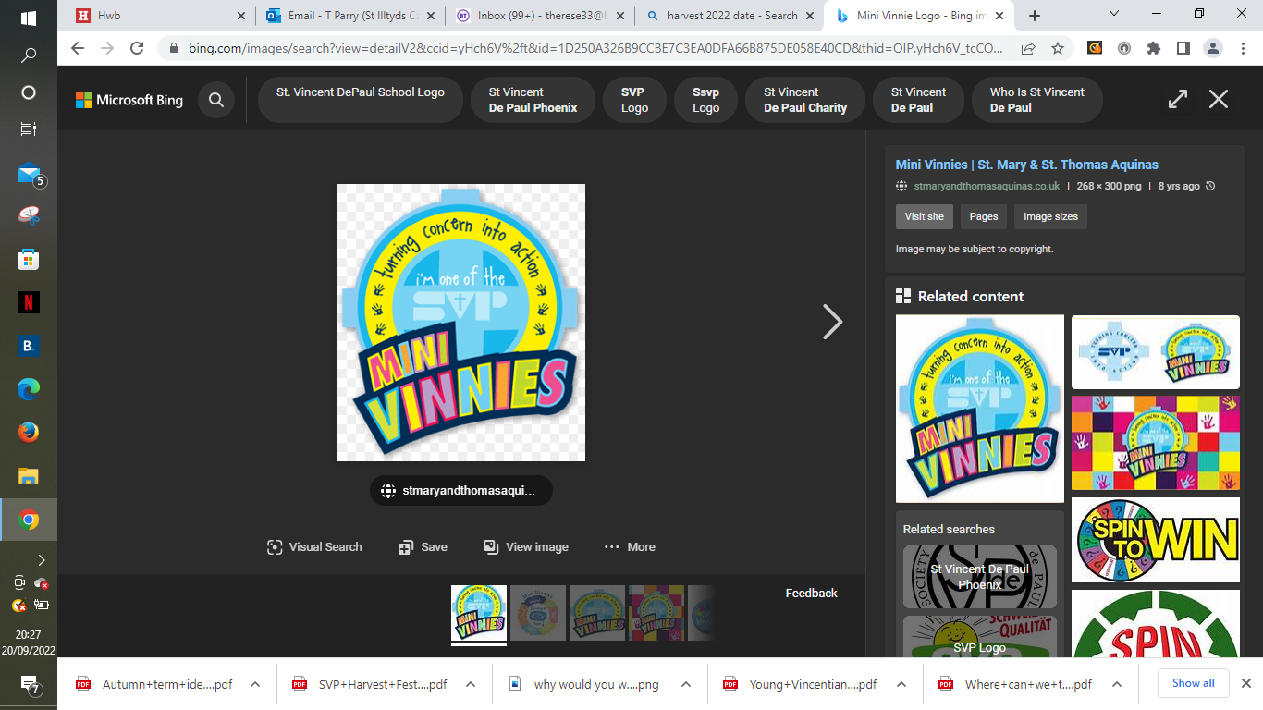We are the Mini Vinnies and we want to make a difference and support our families in the school and local community.

We are celebrating Harvest, which is a time to be thankful for all the food we have.

We need your help!

Please help us by sending in some tinned food/jars of food or sauce/rice or bags of pasta. We will be donating what we collect to our local community.

Please send your donations in until Tuesday 22nd October.

****Thank you for your support

The Mini Vinnies