Please teach RSE using Life to Full programme the first part of the Spring term.

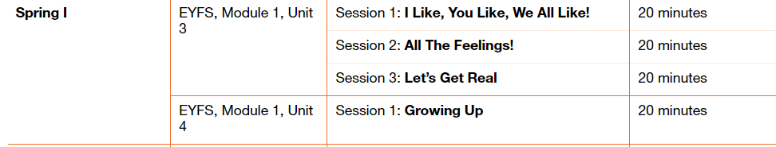

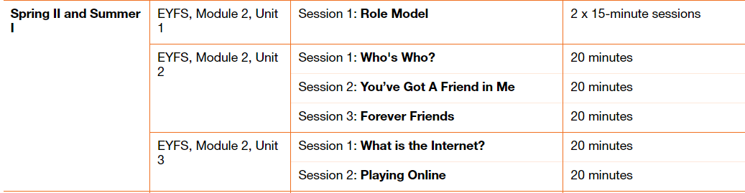

Please fill in the table below showing when you have taught a session. These will be collected in at the end of the term. This gives you the flexibility to teach the sessions as and when.

|  |  |  |
| --- | --- | --- |
| Module and Unit | Session Title | Date completed |
| Nursery  Module 1,  Unit 3  Module 1, unit 4 | I like, you like, we all like!  All the feelings!  Let’s Get Real  Growing up |  |
|  |  |  |
| Reception  Module 2  Unit 1  Module 2  Unit 2 | Role model  Who’s who  You’ve got a friend in me  Forever Friends |  |
| Module 2  Unit 3 | What is the internet?  Playing online |  |
|  |  |  |