Please teach RSE using Life to the Full during the first half of the Spring term

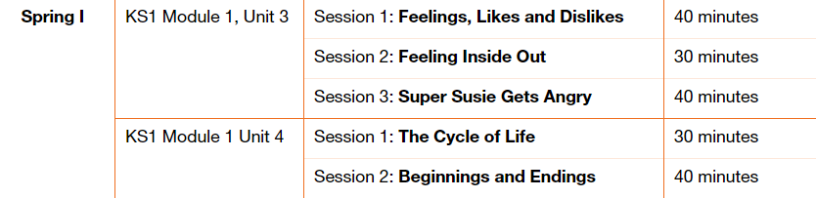

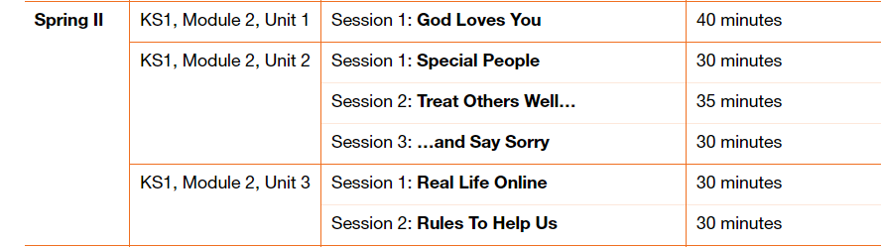

Please fill in the table below showing when you have taught a session. These will be collected in at the end of the term. This gives you the flexibility to teach the sessions as and when.

|  |  |  |
| --- | --- | --- |
| Module and Unit | Session Title | Date completed |
| Year 1  Module 1,  Unit 3 | Feelings, Likes and Dislikes  Feeling Inside Out  Super Susie Gets Angry  The cycle of life  Beginnings and Endings |  |
| Year 2  Module 2  Unit 1 and 2 | God love you  Special People  Treat Others Well  …… and say sorry |  |
| Year 2  Module 2  Unit 3 | Real Life Online |  |
|  | Rules to Help Us |  |
|  |  |  |