Please teach RSE using Life to the Full during the first part of the Spring term.

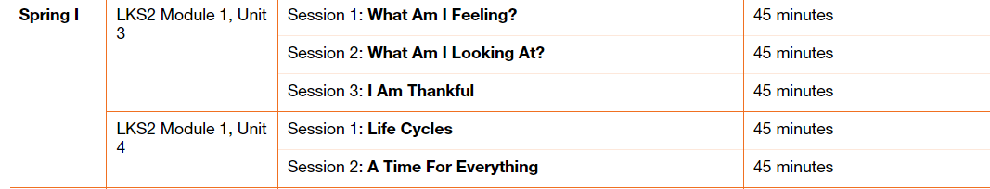

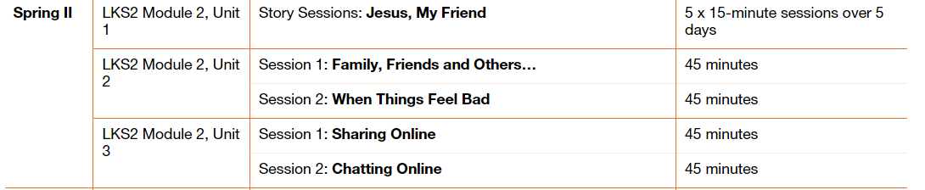

Please fill in the table below showing when you have taught a session. These will be collected in at the end of the term. This gives you the flexibility to teach the sessions as and when.

|  |  |  |
| --- | --- | --- |
| Module and Unit | Session Title | Date completed |
| Year 3  Module 1,  Unit 3  Unit 4 | What am I feeling?  What Am I looking At?  I Am Thankful  Life cycles  A time for everything |  |
|  |  |  |
| Year 4  Module 2  Unit 1  Unit 2  Unit 3 | Jesus, My Friend  Family, friends and others……  When things feel bad  Sharing online  Chatting online |  |