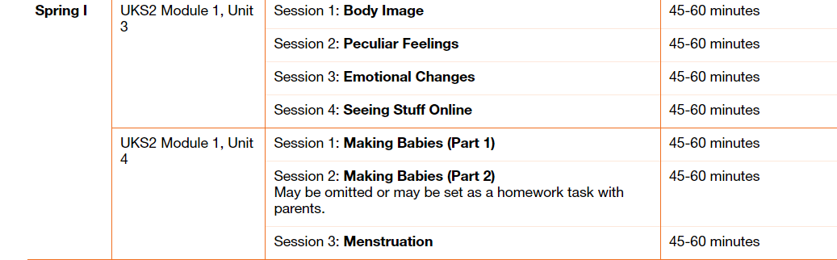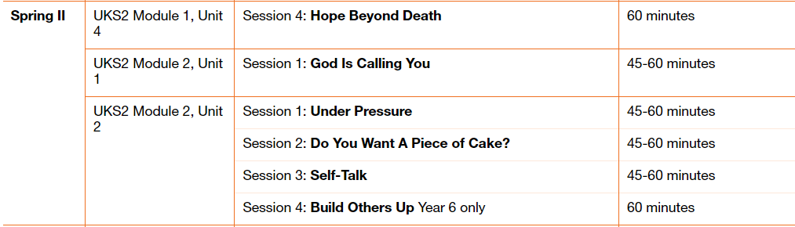Please teach RSE using Life to the Full for the first part of the Spring term.

Please fill in the table below showing when you have taught a session. These will be collected in at the end of the term. This gives you the flexibility to teach the sessions as and when.

|  |  |  |
| --- | --- | --- |
| Module and Unit | Session Title | Date completed |
| Year 5  Module 1,  Unit 4  Module 2  Unit 1  Module 2  Unit 2 | Hope beyond death  God is calling you  Under pressure  Do you want a piece of cake?  Self talk  Build others up |  |
| Year 6  Module 1,  Unit 3  Module 1  Unit 4 | Body image  Peculiar feelings  Emotional changes  Seeing stuff online  Making Babies (part 1)  Making Babies (part 2)  Menstruation |  |