****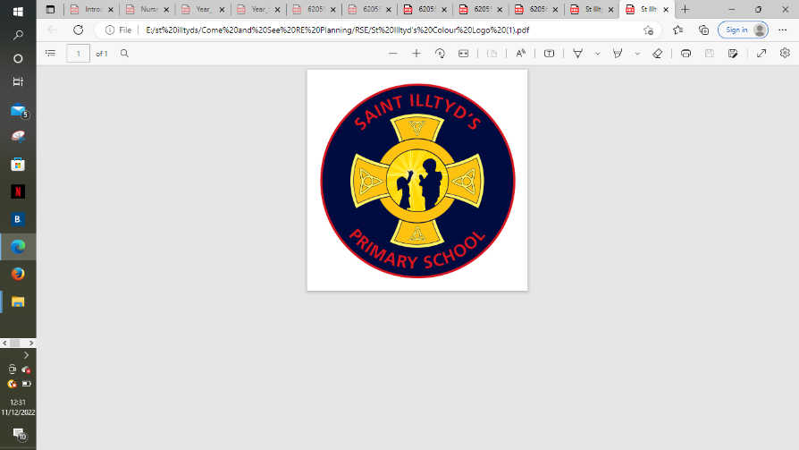 **St. Illtyd’s RC Primary School**

**Come and See overview – Spring Term 2024**

|  |  |  |  |  |
| --- | --- | --- | --- | --- |
| Spring Term | Local Church  3 weeks  Jan 8th – Jan 26th  **Early Years - CELEbrating -** People celebrate in Church  **Year 1 - special people -** People in the parish family  **Year 2 - Books -** The books used in Church  **Year 3 - Journeys -** Christian family’s journey with Christ  **Year 4 - Community -** Life in the local Christian community and ministries in the parish  **Year 5 - mission -** Continuing Jesus’ mission in diocese (ecumenism)  **Year 6 - sources -** the Bible, the special book for the Church | **Formal Assessment Eucharist**  3 weeks  Jan 29th – Feb 23rd  **Early Years - gathering -** Parish family gathers to celebrate Eucharist  **Year 1 - meals -** Mass, Jesus’ special meal  **Year 2 - thanksgiving -** Mass, a special time to thank God  **Year 3 - listening & Sharing -** Jesus gives himself to us  **Year 4 - giving & receiving -** Living in communion  **Sacramental Preparation Class**  Celebrating The Mass - What do Catholics Believe and Do?  **Year 5 - memorial Sacrifice -** Eucharist as the living memorial of Christ’s sacrifice  **Year 6 - unity -** Eucharist enabling people to live in communion | **Lent/Easter**  **4 weeks**  **Feb 26th – 22nd Mar**  **Early Year - growing -** Looking forward to Easter  **Year 1 - change -** Lent: a time for change  **Year 2 - opportunities -** Lent: an opportunity to start anew  **Year 3 - giving all -** Lent: remembering Jesus’ total giving  **Year 4 - self discipline -** Celebrating growth to new life  **Year 5 - sacrifice -** Lent: a time of aligning with the sacrifice made by Jesus  **Year 6 - death & new life -** Celebrating Jesus’ death and resurrection | St. Illtyd’s Pupil Profile  **First half term**  **Compassionate towards others, near and far, especially the less fortunate: and loving by our actions and forgiving words.**  **Second half term**  **Faith filled in our beliefs and hopeful for the future.** |