****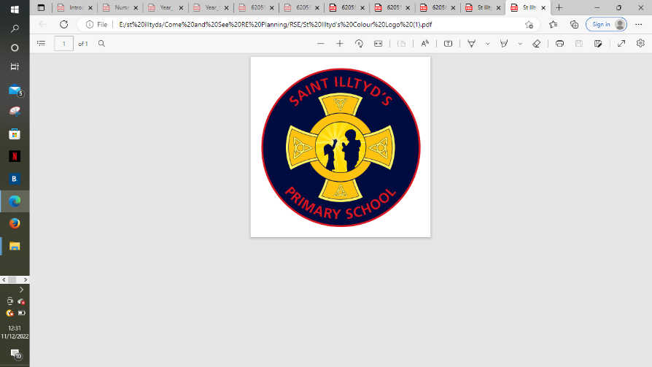 **St. Illtyd’s RC Primary School**

**Come and See overview – Spring Term**

|  |  |  |  |  |
| --- | --- | --- | --- | --- |
| Spring Term | Local Church  3 weeks  Jan 9th – Jan 27th  **Early Years - CELEbrating -** People celebrate in Church  **Year 1 - special people -** People in the parish family  **Year 2 - Books -** The books used in Church  **Year 3 - Journeys -** Christian family’s journey with Christ  **Year 4 - Community -** Life in the local Christian community and ministries in the parish  **Year 5 - mission -** Continuing Jesus’ mission in diocese (ecumenism)  **Year 6 - sources -** the Bible, the special book for the Church | **Formal Assessment Eucharist**  4 weeks  Jan 30th – Mar 3rd  **Early Years - gathering -** Parish family gathers to celebrate Eucharist  **Year 1 - meals -** Mass, Jesus’ special meal  **Year 2 - thanksgiving -** Mass, a special time to thank God  **Year 3 - listening & Sharing -** Jesus gives himself to us  **Year 4 - giving & receiving -** Living in communion  **Sacramental Preparation Class**  Celebrating The Mass - What do Catholics Believe and Do?  **Year 5 - memorial Sacrifice -** Eucharist as the living memorial of Christ’s sacrifice  **Year 6 - unity -** Eucharist enabling people to live in communion | Lent/Easter  4 weeks  Mar 6th – 31st Mar  **Early Year - growing -** Looking forward to Easter  **Year 1 - change -** Lent: a time for change  **Year 2 - opportunities -** Lent: an opportunity to start anew  **Year 3 - giving all -** Lent: remembering Jesus’ total giving  **Year 4 - self discipline -** Celebrating growth to new life  **Year 5 - sacrifice -** Lent: a time of aligning with the sacrifice made by Jesus  **Year 6 - death & new life -** Celebrating Jesus’ death and resurrection | St. Illtyd’s Pupil Profile  **First half term**  **Eloquent and Truthful**  Pupils are growing to be **eloquent and truthful** in what they say of themselves, the relations between people, and the world.  **Second half term**  **Learned and Wise**  Pupils are growing to be **learned,** finding God in all things; and **wise** in the ways they use their learning for the common good. |