****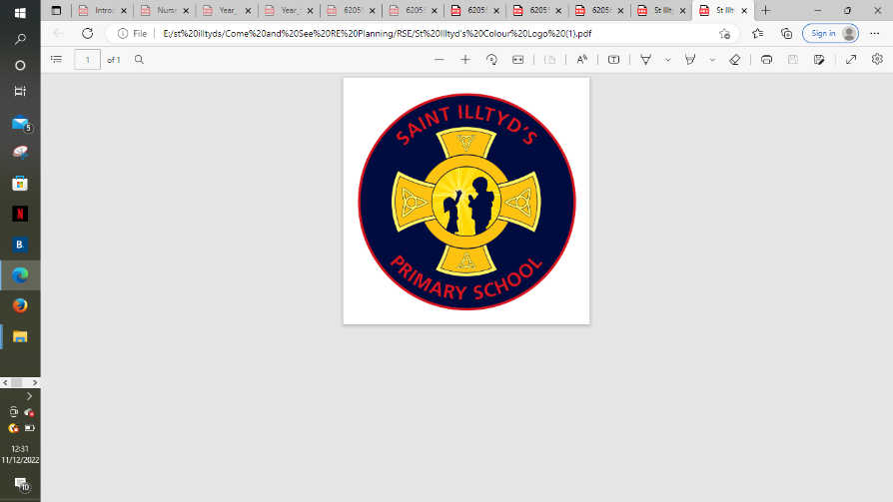 **St. Illtyd’s RC Primary School**

**Come and See overview – Summer Term**

|  |  |  |  |  |  |
| --- | --- | --- | --- | --- | --- |
| SummerTerm | **Pentecost**  **4 weeks**  **17th April – 12th May**  **Early Years - Good News**  What is good news?  **Year 1 - Holidays & holydays**  Do we need holidays and holydays?  **Year 2 - Spread the word**  Why should we spread Good News?  **Year 3 - Energy**  What’s the use of energy?    **Year 4 - New life**  What’s so important about new life?  **Year 5 - Transformation**  How can energy transform?  **Year 6 - Witnesses**  What do I want to witness to in my life? | **Reconciliation**    **4 weeks**  **15th May – 16th June**  **Early Years - Friends**  Is it good to have friends?  **Year 1 - Being sorry**  Why should we be sorry?  **Year 2 - Rules**  Do we need rules?  **Year 3 - Choices**  What helps me to choose well?  **Year 4 - Building bridges**  Why are bridge-builders important in life?  **Year 5 - Freedom & responsibility**  How do rules bring freedom?  **Year 6 - Healing**  Who needs healing? | **Other Faith**  Islam  19th June – 23rd June | **Formal Assessment**  **Universal Church**  **4 weeks**  **26th June – 21st July**  **Early Years - Our world**  What makes our world so wonderful?  **Year 1 - Neighbours**  Who is my neighbour?  **Year 2 - Treasures**  Is the world a treasure?  **Year 3 - Special places**  What makes a place special?  **Year 4 - God’s people**  Why do some people do extraordinary things?  **Year 5 - Stewardship**  Can I be a steward of creation?  **Year 6 - Common good**  How can we work together to build a just and fair world? | St. Illtyd’s Pupil Profile  **First half term**  **Curious and Active**  Pupils are growing to be curious about everything; and active in their engagement with the world, changing what they can for the better.  **Second half term**  **Intentional and Prophetic**  Pupils are growing to be intentional in the way they live and use the resources of the earth, guided by conscience; and prophetic in the example they set to others. |