**St. Illtyd’s Pupil Profile 2023 – 2024**

We focus on a pair of virtues every half term.

Quote from Pope Benedict

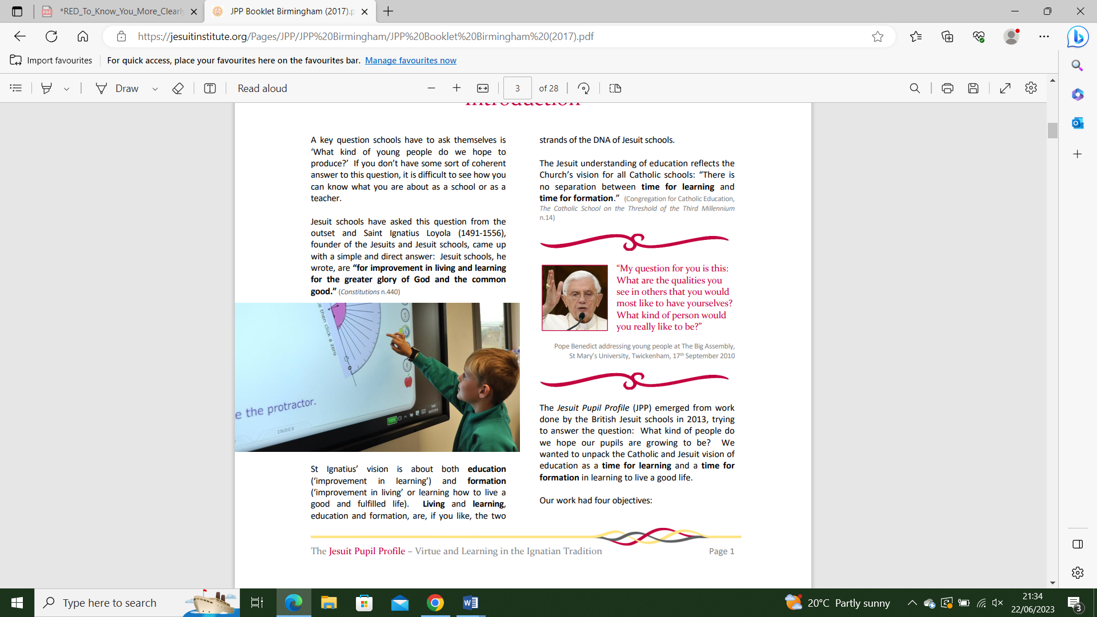

|  |  |  |
| --- | --- | --- |
| **Term 1**  First Half  Sept/Oct 2023 | Grateful & Generous | Pupils are growing to be **grateful** for their own gifts, for the gift of other people, and for the blessings of each day; and **generous** with their gifts, becoming men and women for others. |
| **Term 1**  Second half  Nov/Dec  2023 | Attentive & Discerning | Pupils are growing to be **attentive** to their experience and to their vocation; and **discerning** about the choices they make and the effects of those choices. |
| **Term 2**  First half  Jan/Feb  2024 | Compassionate & Loving | Pupils are growing to be **compassionate** towards others, near and far, especially the less fortunate; and **loving** by their just actions and forgiving words. |
| **Term 2**  Second half  Mar/Apr  2024 | Faith-Filled & Hopeful | Pupils are growing to be **faith-filled** in their beliefs and **hopeful** for the future. |
| **Term 3**  First half  May/June  2024 | Eloquent & Truthful | Pupils are growing to be **eloquen**t and **truthful** in what they say of themselves, the relations between people, and the world. |
| **Term 3**  Second half  June/July  2024 | Learned & Wise | Pupils are growing to be **learned,** finding God in all things; and **wise** in the ways they use their learning for the common good. |